HairVise
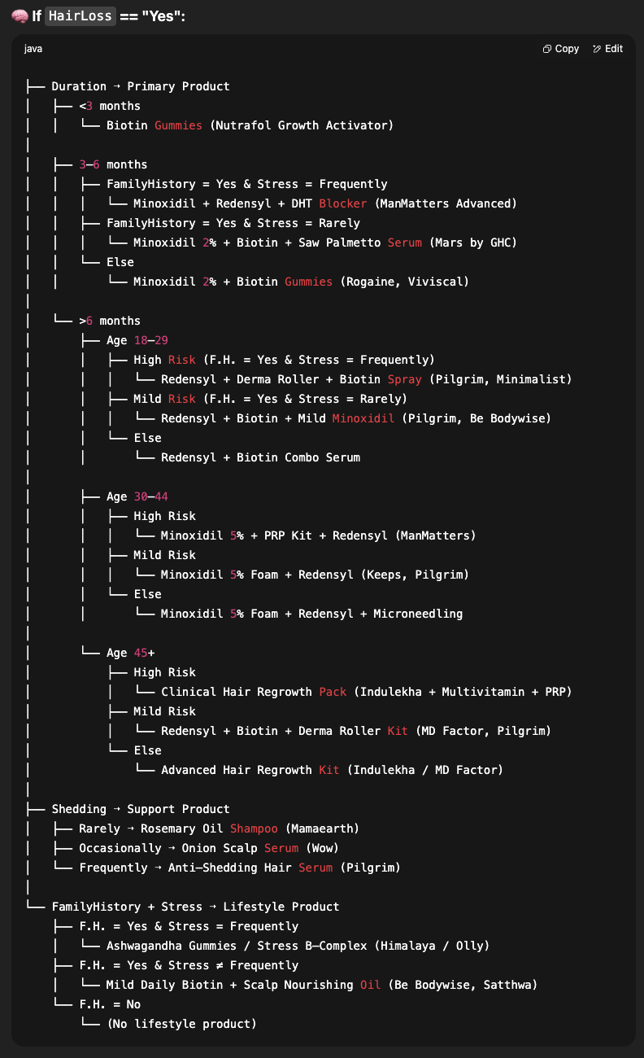
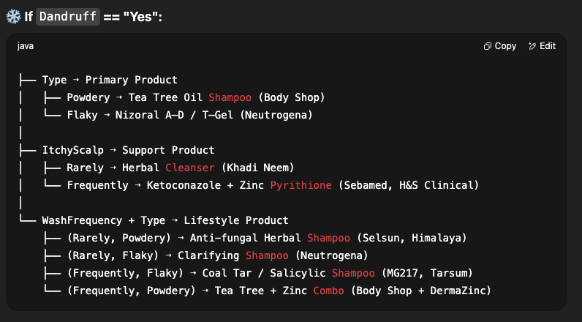
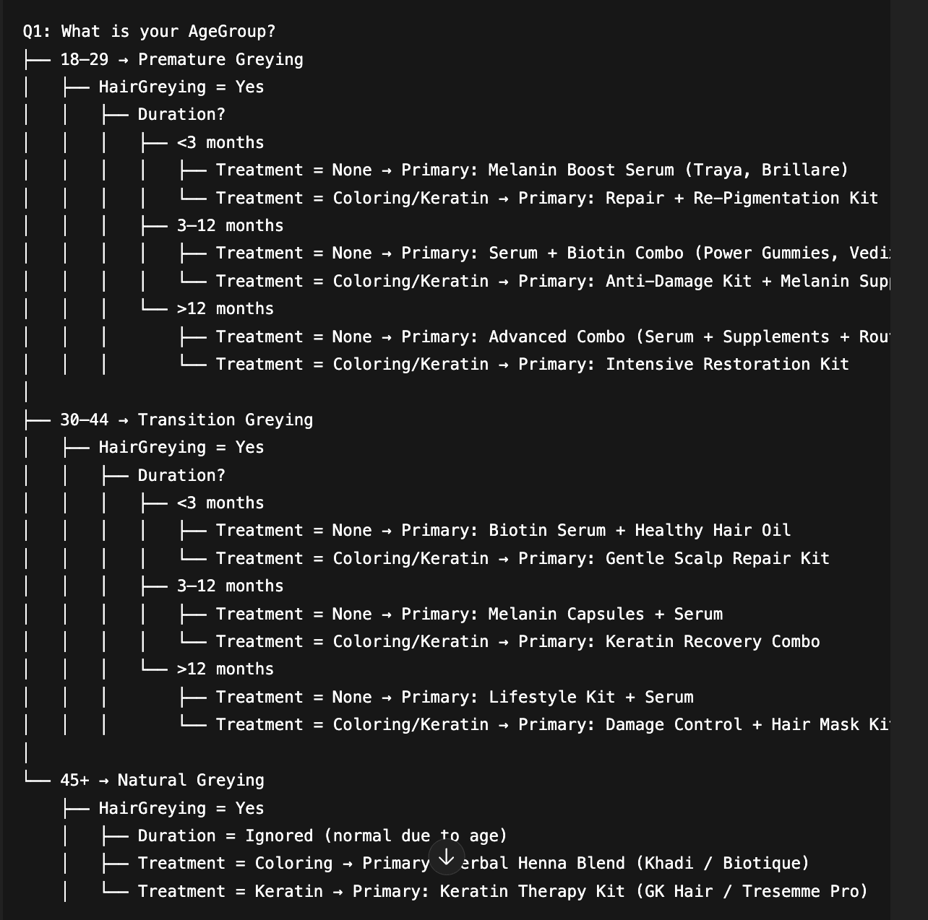

🔢 Suitable Algorithms & Models for Multi-Label Classification

🔁 Traditional ML Models (with One-vs-Rest or MultiOutputClassifier wrappers):
- Logistic Regression
- Random Forest Classifier
- Decision Tree Classifier
- K-Nearest Neighbors (KNN)
- Support Vector Machine (SVM) – not ideal for large datasets but possible
- Naive Bayes – (can be adapted for binary outputs but not preferred for multi-label)
- XGBoost Classifier – very powerful with MultiOutputClassifier
➡️ Use with wrapper:
from sklearn.multioutput import MultiOutputClassifier
from sklearn.linear_model import LogisticRegression

model = MultiOutputClassifier(LogisticRegression())

🤖 Neural Networks:
- Keras/TensorFlow Fully Connected Neural Network (FCNN) – most flexible
  - Output layer: Dense(len(target_columns), activation='sigmoid')
  - Loss: binary_crossentropy
  - Output is multi-label binary vector.
➡️ Perfect for learning interactions between features.

🧠 Advanced / Ensemble Approaches:
- XGBoost + OneVsRestClassifier
- LightGBM + MultiOutputClassifier
- CatBoost Multi-label
- MLkNN (Multi-label k-NN) – from scikit-multilearn (advanced library)
- Classifier Chains – from scikit-multilearn
- Label Powerset – converts multi-label to multiclass problem internally (less preferred if labels are sparse)

🔍 Recommended Starting Models:
For your case, I’d recommend trying:
- ✅ Logistic Regression + MultiOutputClassifier (Baseline)
- ✅ Random Forest + MultiOutputClassifier
- ✅ XGBoost + MultiOutputClassifier
- ✅ Keras Neural Network with sigmoid output
- ✅ MLkNN (optional – for experimentation)
Would you like me to give you a sample implementation of these models (with training and evaluation) on your current dataset (df) next?

